MAILING ADDRESS: PO BOX 5447, GREENSBORO, NORTH CAROLINA 27435
ADMINISTRATIVE OFFICES: 1921 WEST LEE STREET, GREENSBORO, NORTH CAROLINA 27403 TELEPHONE: 336-373-7400 FAX: 336-373-2170 BOX OFFICE FAX: 336-373-7413 MARKETING FAX: 336-218-5597 www.greensborocoliseum.com

July 7, 2014

Mr. Ermon Rush
Image Innovation Group
P.O. Box 6265
High Point, NC 27262

Dear Mr. Rush:

Thank you for providing high quality signage on short delivery schedules for our last two projects at Greensboro Coliseum Complex.

The Coliseum Complex, which is a division of the City of Greensboro, has purchased signage for 2 projects through Image Innovation Group:
- Greensboro Aquatic Center in 2010-11
- Greensboro Coliseum Concourse Expansion in 2013-14

The most recent project was a complete re-make of all new directional and section signage in Greensboro Coliseum public concourses that had a manufacturing turn-around in just seven (7) weeks. More than 450 custom signs were manufactured and installed in this time frame to meet a significant event for the facility in the 2014 ACC Men's Basketball Tournament with more than 110,000 attendees.

Image Innovation Group completed the project before the event and installation was done in record time. We thank you for your extra efforts to meet our time table and in providing high quality signs. We are happy to serve as a reference on future projects you are bidding on.

Sincerely,

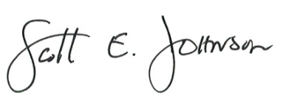

Scott Johnson
Deputy Director
Greensboro Coliseum

